**Instructions for Setting Up a Dev Container**

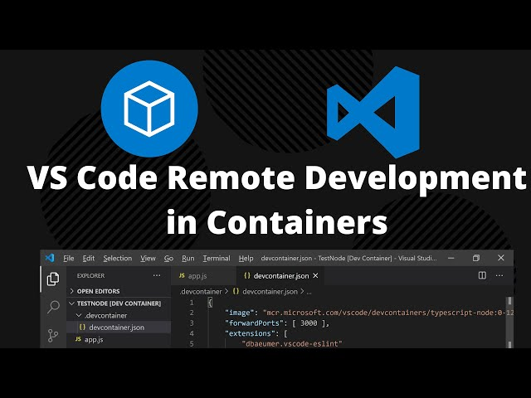

**Kaveh Fathian**

* *Windows*: Install WSL2: <https://learn.microsoft.com/en-us/windows/wsl/install>
* Download and install either Docker Engine or Docker Desktop
  + *Windows*: Download and install Docker Desktop: <https://docs.docker.com/desktop/install/windows-install/>
  + *Linux*: <https://docs.docker.com/engine/install/ubuntu/>
    - Docker Engine (Terminal based; Prefered over Docker Desktop for Ubuntu)
* (if using GPU, e.g., for deep learning) Download and install NVIDIA Container Toolkit
* *Windows/Linux*: Download and install VS Code: <https://code.visualstudio.com/download>
  + Go to VS Code extensions panel (CTRL+Shift+X) and install Dev Containers
  + Install the "Remote Development" extension for Visual Studio Code
* In VS Code, create a folder for your project, go to the folder, and then open the configuration screen (Ctrl+Shift+P) and type/select “Dev Containers: New Dev Container”
  + Follow the steps and select appropriate configurations, e.g., select C++ project, CMake version 3.22, and Ubuntu 22.04
* Installing OpenCV within container:
  + Modify the Dockerfile in the .devcontainer by adding the commands from <https://medium.com/@albertqueralto/installing-opencv-within-docker-containers-for-computer-vision-and-development-a93b46996520>
  + Note when you are building the image for the first time, it will take a long time (15 minutes)

**GUI display**:

* *Linux*:
  + A very important step before running the devcontainer in VS Code is to type in the terminal “xhost +”. This allows you to connect to the X11 display server so you can display any GUI windows.
  + Here's that code snippet to convince the X-server to forward on Linux (goes in devcontainer.json)  
     "containerEnv": {  
     "DISPLAY": "unix:0"  
     },  
     "mounts": [  
     "source=/tmp/.X11-unix,target=/tmp/.X11-unix,type=bind,consistency=cached"  
     ],  
     "runArgs": ["--privileged"]
* *Windows*:
  + Download the vcxsrv installer and run leaving everything at default: <https://sourceforge.net/projects/vcxsrv/>
  + Once installed, run XLaunch in Windows, leaving everything as default.
    - NOTE: use “One large window” when starting XLaunch if your GUI is cropped
  + In .devcontainer>Dockerfile, add   
     ENV DISPLAY=host.docker.internal:0  
    and then build the container
  + Everything should be set & working now!